Server IP: 104.131.67.146

Connect to server via FTP:

In Filezilla Go to File Then Site Manager or use the shortcut CTRL+S

Create a new Site

Under Host Put in 104.131.67.146 you can leave the port blank because we’re using the default port.

Under Protocol select SFTP

Logon Type change to Ask For Password

Username is the username I had you create.

It Should Look Like this:

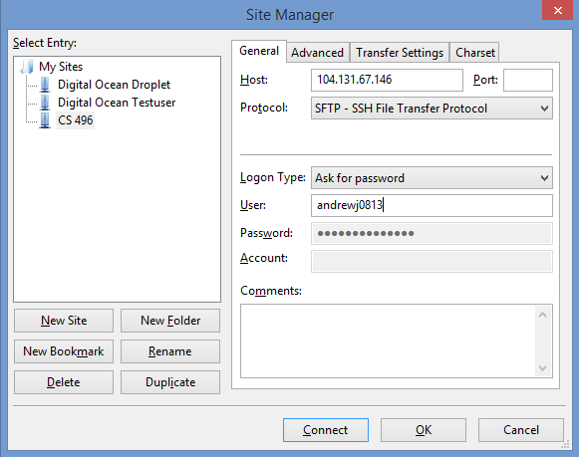

Then just hit Connect. It will prompt you for your password then you’ll be connected.

You each can only edit things inside your own Folders and can’t change anything else anywhere else on the server.

Josh’s Directory:

/var/www/ehaic.com/public_html/Josh

Morgan’s Directory:

/var/www/ehaic.com/public_html/Morgan

Taylor’s Directory:

/var/www/ehaic.com/public_html/Taylor

Anything you guys upload here will be displayed publically at:

Josh:

[www.ehaic.com/Josh](http://www.ehaic.com/Josh)

Morgan:

[www.ehaic.com/Morgan](http://www.ehaic.com/Morgan)

Taylor:

[www.ehaic.com/Taylor](http://www.ehaic.com/Taylor)

Changes might take a bit to display because I’m using Cloudflare as a DNS and my website goes through their content distribution network so it has to update across their network before it will display. Also sometimes you might need to do a cacheless refresh with CTRL+F5 in most browsers.